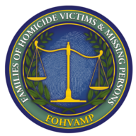
Registration Form

15th Annual Meeting October 1st, 2016

Brittany Hill
Thornton, Colorado

You may register up to two persons on this form. Use a separate registration form for additional persons. Please email this form to kfernandez-kroyer@fohvamp.org. Payment by check or money order can be done the day of the event. If you would like to pay by credit card, please visit www.fohvamp.org and use the donate now button. We look forward to seeing you in October.
Your Name Phone

Address City State ZIP Second Name Phone Address City State ZIP Loved One’s Name Your Relationship Agency Investigating Murder/Disappearance

Registration Fees
Registration is $40 per person $__________
Financial Assistance Requested ___________

Donation to FOHVAMP [Any amount is welcome] $

Payment

Total $

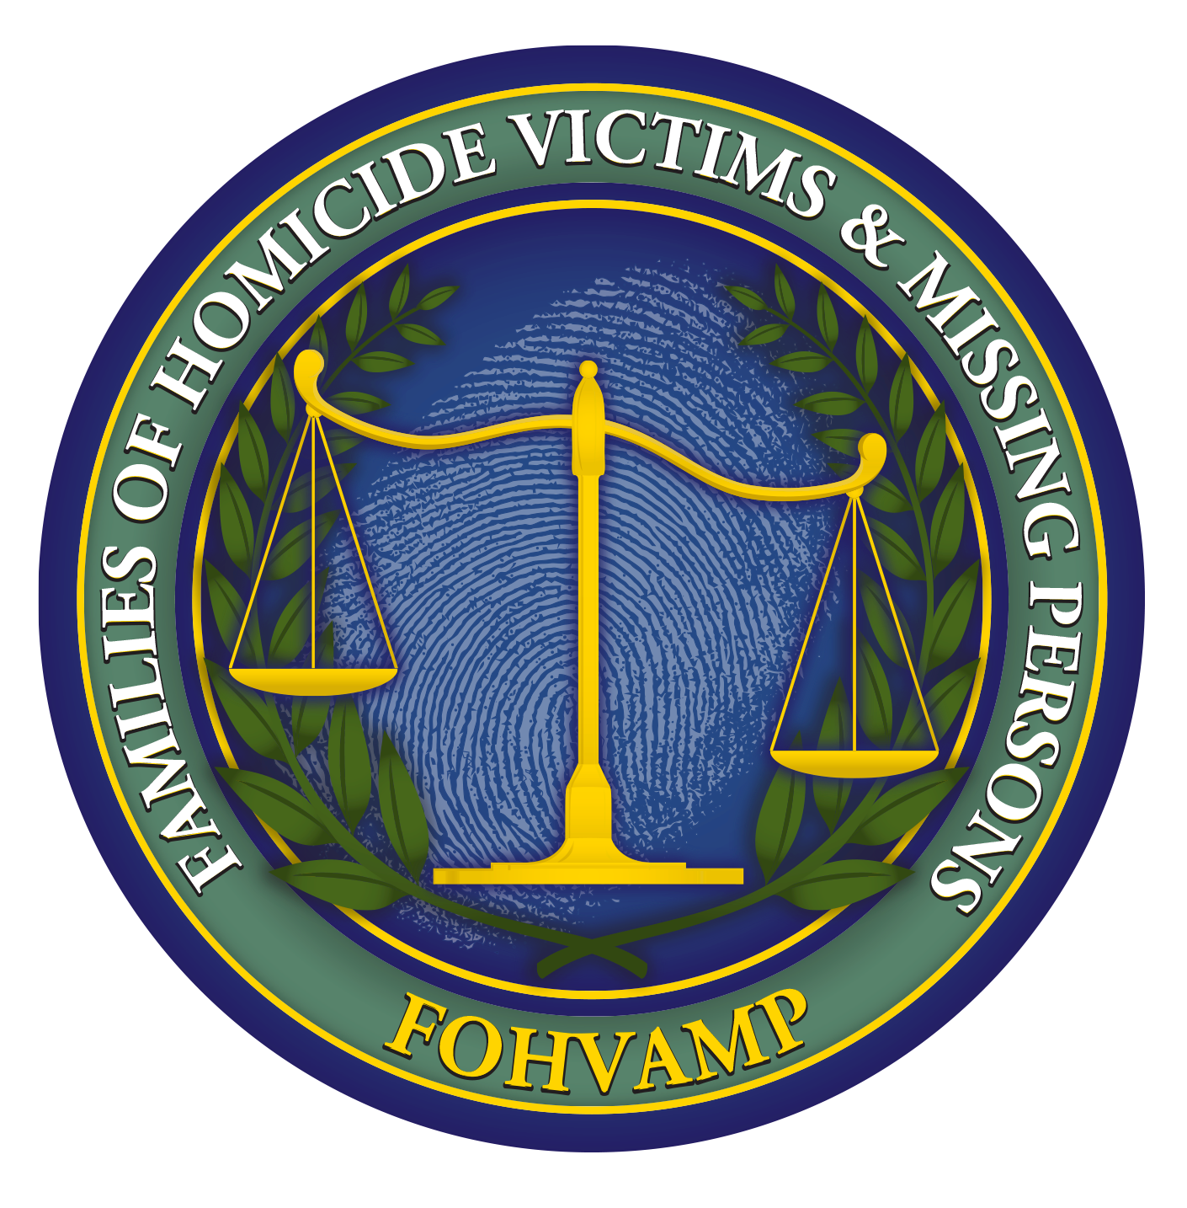
____Check or money order payable to FOHVAMP can be paid at event or ____ Credit Card

[For Credit Cards, please go ON LINE to the FOHVAMP Home Page, http://www.fohvamp.org and use the Donate Now button]
[Please email this form to Kelly Fernandez-Kroyer at kfernandez-kroyer@fohvamp.org]

